**Machine-Learning Oxybarometer Developed Using Zircon Trace-element Chemistry and Its Applications**

**Shaohao Zou1*, Matthew J. Brzozowski2, Xilian Chen1, Cheng-Biao Leng1, Deru Xu1**

1State Key Laboratory of Nuclear Resources and Environment, East China University of Technology, Nanchang 330013, China

2Department of Geology, Lakehead University, Thunder Bay, Ontario P7B 5E1, Canada

Corresponding author: Shaohao Zou (shaohaozou@hotmail.com)

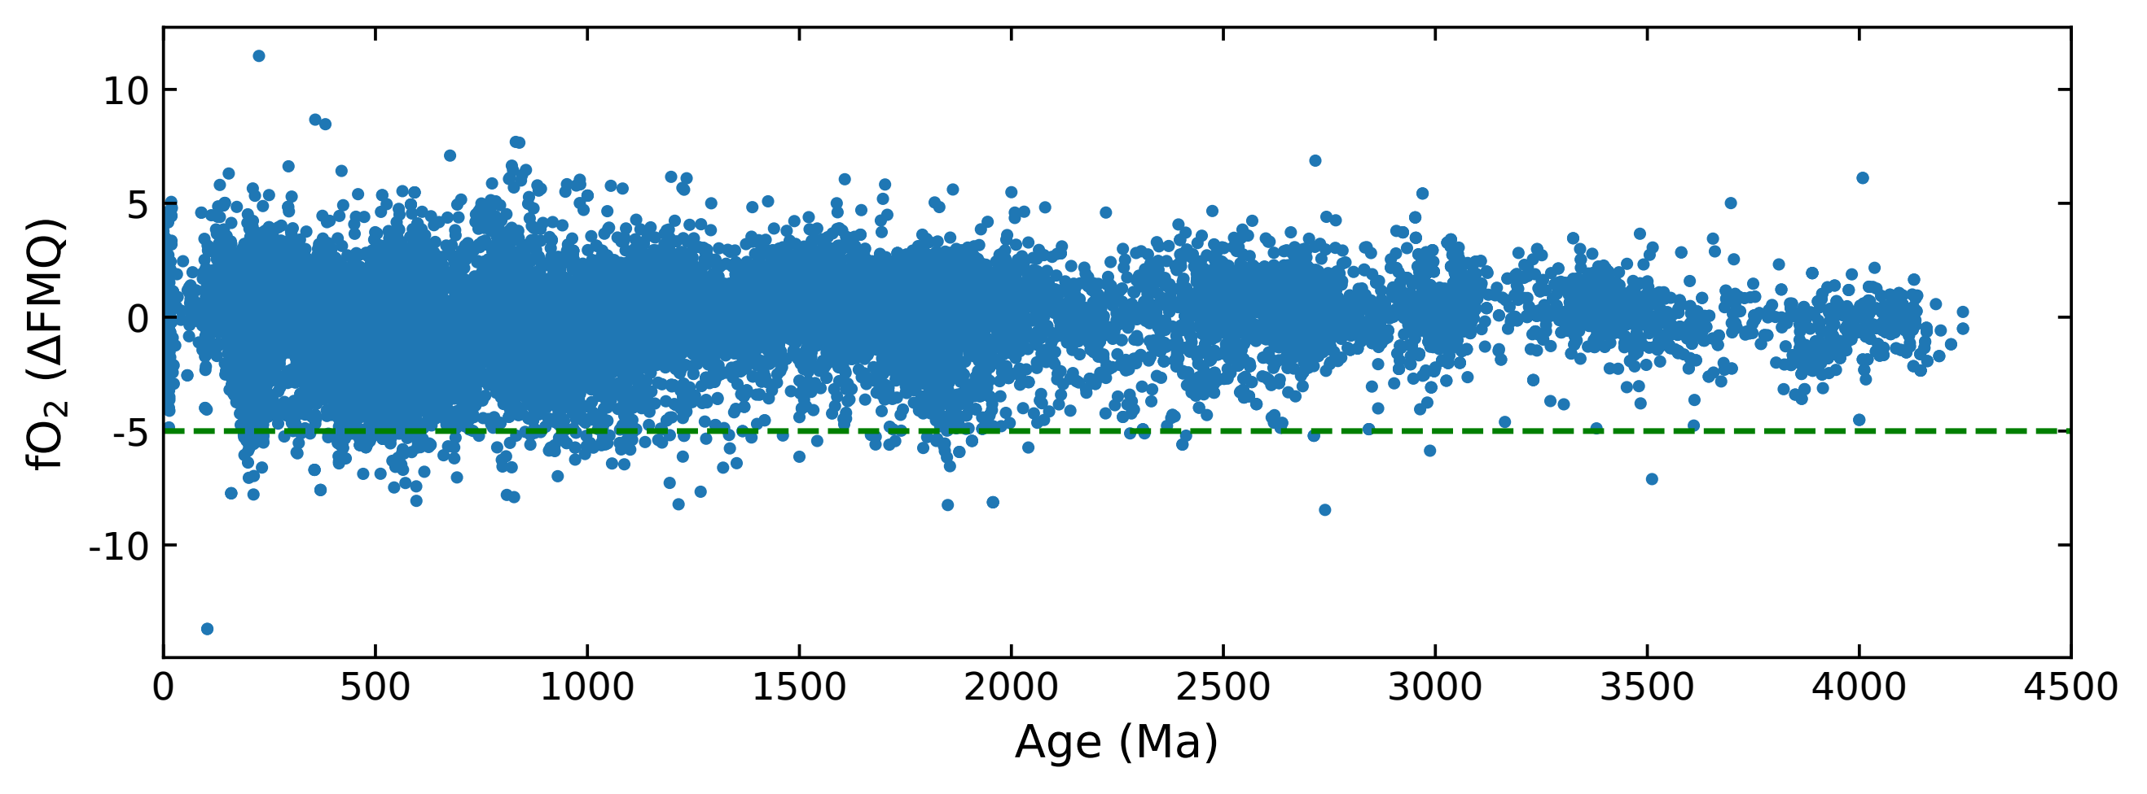

**Figure S1.** The *f*O2 values versus age diagram. The *f*O2 values are calculated by the U–Ti–Ce equation using trace elements of global detrital zircon database from Tang et al. (2021) and Verdel et al. (2021) and reference therein.

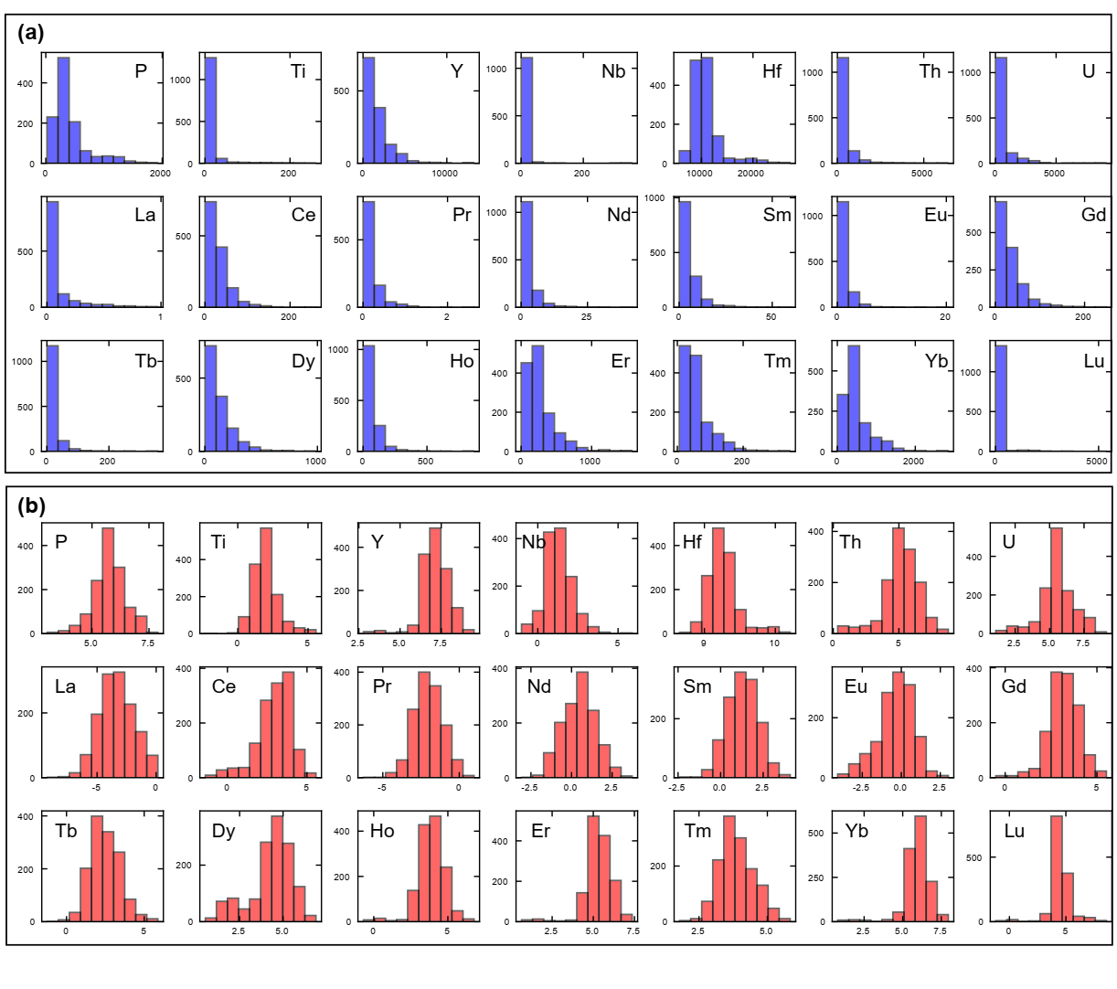

**Figure S2.** Histograms diagrams showing elements distribution (a) before (in blue color) and (b) after (in red color) log-transformation.

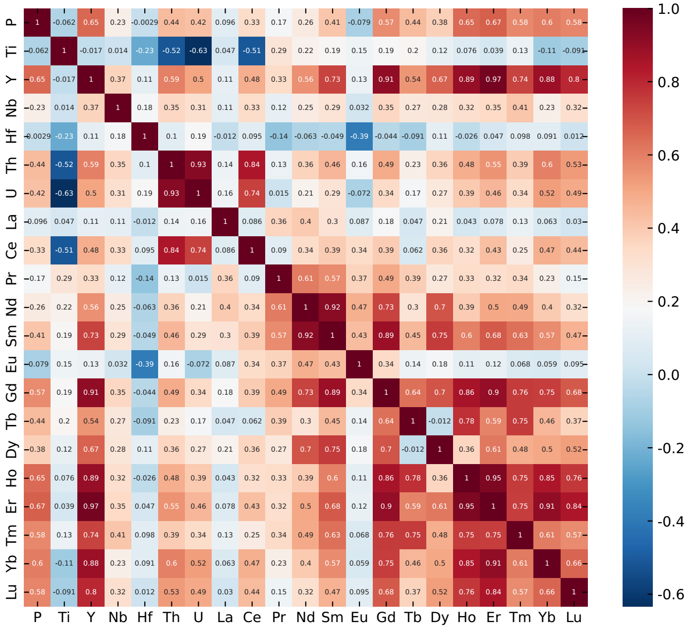

**Figure S3.** Spearman’s correlation heatmap of the data showing both strong (higher absolute value in red or blue color) and weak (lower absolute value in white color) correlation between elements.

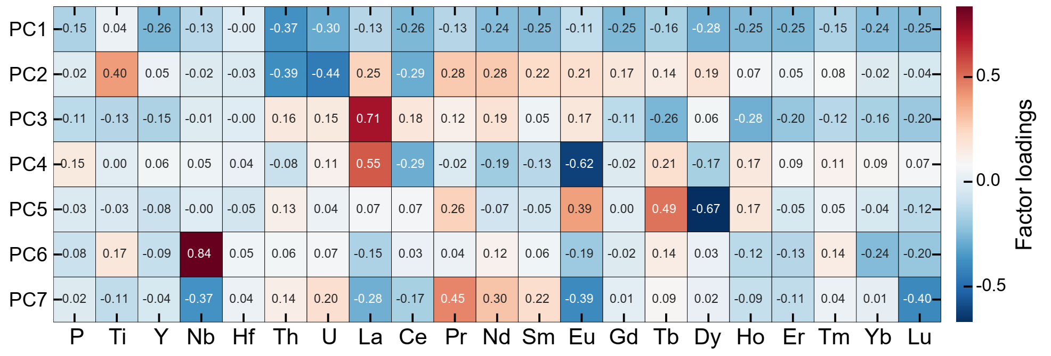

**Figure S4**. Heatmaps showing the loadings for each element in the first seven PCs. The absolute-size of loadings indicates the contribution of the variable to the PCs, which means that the higher absolute-size of factor loadings, the more variance of the original data it explains.

**References:**

Tang, M., Chu, X., Hao, J., & Shen, B. (2021). Orogenic quiescence in Earth’s middle age. *Science*, *371*(6530), 728–731. https://doi.org/10.1126/science.abf1876

Verdel, C., Campbell, M. J., & Allen, C. M. (2021). Detrital zircon petrochronology of central Australia, and implications for the secular record of zircon trace element composition. *Geosphere*, *17*(2), 538–560. https://doi.org/10.1130/GES02300.1